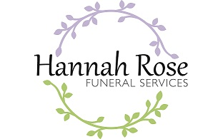
CREMATORIA PRICE INFORMATION 2026
The information below, gives the prices charged by Crematoriums for an adult (16 + years) funeral within a 40-minute cortege journey of this funeral home.
Woodlands Crematorium, Scarborough
Standard Fee Attended Service (60- minutes) 11am – 3pm £1095
Standard Fee Attended Service (45- minutes) 9.15am £725
Unattended Service (NO Service) 8.30am, 8.45am £483
East Riding Crematorium, Octon
Standard Fee Attended Service (60- minutes) 10.30am – 4.30pm Mon - Wed £1330
Standard Fee Attended Service (60- minutes) 10.30am – 4.30pm Thursday/Friday £1430
Reduced Service Fee (9.30am Service) £900
Direct Attended Service (NO Service) (No music or Officiant) 8.15am, 8.20am £795
Direct Unattended Service 8.15am, 8.20am £575
Saturday Service /Sunday Service £1430
TERMS OF BUSINESS Our Terms of Business include the following:
You must pay a deposit of 50% or of the total no later than 1 day before the funeral takes place. DWP clients could be exempt*
The final balance must be paid within 14 days after the funeral. DWP clients are exempt*
The following charges will be made for late payment* (£50 for each additional 7 days). DWP clients are exempt*
**Other payment options are DWP, BACS, Cash, Cheque
DISCLOSURE OF INTERESTS
The ultimate owner of the business is Laura J. Moseley T/A Hannah Rose Funeral Services
We have no business or financial interest in a price comparison website which compares Funeral Director Services and/or Crematoria Services and their respective prices.
Register of charitable donations and gratuities
This is available on request. This includes gifts at Christmas and gifts to care environments for charity raffles.

